The Staff of the Netherlight Magi

Price (Market): 311,000 gp; Body Slot: one-handed weapon; Caster Level: 20th; Aura: Strong; (DC 23) Varied; Activation: Continuous; Weight: 2 lbs.

DESCRIPTION
“The Staff of the NetherLight Magi is a very potent magic item, awakening within its wielder locked away magical potential. The staff is topped with a glistening gem, its shaft straight and smooth, and near the top of the staff resides a mana welded ring of wizardry fused to the staff”
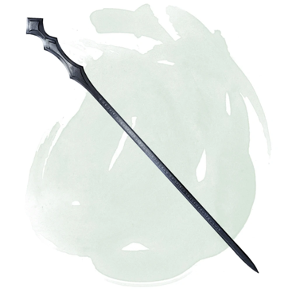
The wielder of the Staff of NetherLight gains a +2-luck bonus to AC and saving throws. The staff is also a +5 quarterstaff. While used the Staff radiates a magical light in a 60’ radius that pierces both magical and non-magical darkness.

Once attuned the staff will impart the following benefits:

- Awakens and grants access to all spell slots across a character’s casting classes, and ability modifier related bonus spells as normal.
- The newly awakened spell slots can act as a magic buffer; Allowing a caster to configure the spells they prepare within that buffer up to the maximum allowed (sum total of overall spell slot levels). An example of this is they can take a 4th level spell slot and a 5th level spell slot and use them to cast a prepared 9th level spell.
- Latent affect, but once the 10e caster grows beyond 18th level they get expanded ability modifiers and bonus spells beyond ninth level (present table stops at 9th level spells); See Table: Expanded Ability Modifiers and Bonus Spells.
- Gains access to the energy type - Quasi-elemental – Radiance

Lastly, provided the wielder is attuned to the staff, the wielder can call the vest to them if they are anywhere on the same plane. Speaking the proper command word, regardless of the intervening distance. (as Called; MIC pg. 9)

Activation: Continuous
Restriction (Racial): n/a
Body Slot: one-handed weapon
Category: Non-Epic

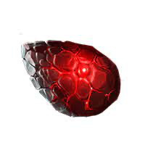
SOCKET
Blood Stone
“As a casters spell slots return, the caster gains one extra spell slot in their daily allotment, at any level up to one lower than the highest level of spell you can currently cast.”
Function: (continuous) You can cast an additional spell. (as Extra Slot Feat)
Price:+1

MANAWELDER
Ring of Wizardry
“The wearer’s arcane spells per day are doubled for spell levels I - IV.”
Function: (continuous) The wearer’s arcane spells slots per day are doubled for spell levels one thru four.
Price: 178,000 gp

CONSTRUCTION REQUIREMENTS
Aura: (Strong) Varies
Caster Level: 20
Craft Feats: Craft Staff
Craft Skill: Dwarvencraft [DC23]; Jewelcrafting [DC21]
Socket (1): Blood Stone [as Extra Slot feat]
Dwarven Runes: n/a
Material Components: Adamantium (3x bars); Manacite (Very Rare); Blue Diamond (1x); Spellbreaker (1x);
Alchemical Reagents: Dragon Bone; Manaethereal Troll Tusk Ivory (4x)
Item Properties: Reinforced [1,200gp]; Socket [1,200gp]; Dwarvencraft [600gp]
Special Abilities: Called [+1]; Blueshine [+1]
Spell Prerequisites: wish, reality revision, daylight w/ radiance
Forge/Tools: Elemental Forge; Anvil of Fire, Mana-welder, Runehammer, Gemcarver’s Tools, Manawelder, Molecular-Bonder

