Great Crossbow, Dwarven Mauler

Price (Market): 191,500 gp; Body Slot: two-handed; Caster Level: 20th; Aura: Medium; (DC 21) Transmutation; Activation: Swift; Weight: 20 lbs.

DESCRIPTION
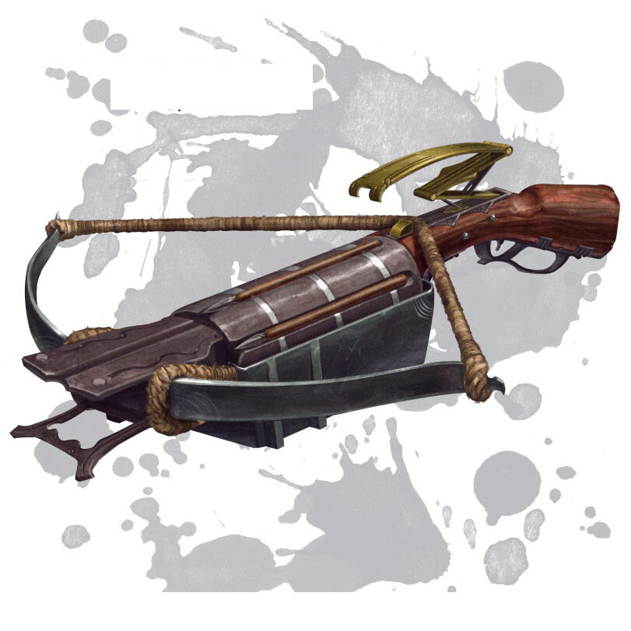
“This Huge +5 Heavy Crossbow of Reloading is covered with dwarven runes, and the intricate stock has been carved to resemble the head of a hammer. Because of its increased size and runic magic, bolts fired from the dwarven mauler increase in size and density before they strike their target, dealing 6d8 points of damage on a successful hit.

The increase in the size of this crossbow does not affect the time it takes to load the crossbow, decorated with ancient symbols of wind and energy along its handle. Holding up to 8 crossbow bolts, if it holds bolts it can be reloaded by pulling the reloading lever (a free action). Loading a new case of bolts takes swift action.
Along the sides toward the bottom of the crossbow are four thin hollow chambers equipped to hold up to four wands. The wielder of this crossbow has access to any wands loaded in the chambers and can activate up to two with a standard action.

Furthermore, against all giants and goblinoids, the dwarven mauler's critical multiplier is increased to x4.”

This great crossbow confers the following benefits:

- Enhancement Bonus: +6 To Hit and Damage
- Damage: 6d8
- Range Increment: 120ft
- Critical Threat Range: 19-20
- Critical Multiplier: x3 / x4 (Giants, and Goblinoids)
- Damage Type: Piercing
- 4 Wand Chambers – Can activate upto two at the same time (as dual wand wielder)
- See reload rules in the Description.

Activation: Free action / Standard action
Restriction (Racial): Dwarves
Body Slot: Two-Handed
Category: Non-Epic

RUNE
Rune of Wind

“A special contingent of Dwarves from the Mithril Hall, known as the Mauler line, are specifically trained with Dwarven Great Crossbows (i.e. Mauler Crossbows) to defend against the massive numbers of goblinoids. This line could chamber the next bolt with lightning speed.
Function: (continuous) Renders the weapon near weightless, allowing the reloading action lever to be near frictionless activating as a free action.
Price: +2

RUNE
Rune of Speed
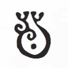
“This rune passed on to dwarven rune crafters and is typically used to hasten the crossbow line in reloading the Bolt Cartridge.”
Function: (continuous) Allows the dwarven crossbowman to reload the bolt cartridge in this crossbow as a swift action.
Price: +2

CONSTRUCTION REQUIREMENTS
Aura: (Medium) Transmutation
Caster Level: 20
Craft Feats: Craft Arms and Armor
Craft Skill: Dwarvencraft [21]
Socket(1): (empty)
Dwarven Runes: Wind and Speed
Wand Chambers: (empty)
Material Components: Mithril (1x Bars); Ironwood (4x), Manacite (Very Rare); Spellbreaker (1x);
Alchemical Reagents: Woven Cloud Giant Hair, Dragon Leather, ManaEthereal Troll Ivory Tusks
Item Properties: Socket [+1,200gp]; Dwarvencraft [+600gp]
Special Abilities: Blueshine [+1]; Called[+1];
Spell Prerequisites: Animated Object, Gravity Bow, Leomund’s Secret Chest, Limited Wish
Forge/Tools: Elemental Forge; Anvil of Fire, Mana-welder, Runehammer, Molecular-Bonder

