Ancient Reaver +8/+10 (Surge II)

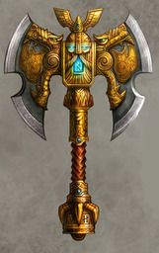
Weapon: (Huge) Greataxe; Martial Two-Handed Melee
Type: Slashing
Critical: x3
Critical Range: 20

Base Weapon Damage: 4d6 (Huge) x4 (metal folding)/17-20 (serrated, keen) + 1d8 (adrenaline surge, surge II weapon ability)

Enchantment: +5 to-hit, and damage – enchantment bonus

Dwarven Forge Craft: Masterwork (+1 to hit), Metal Folding (+1 damage, +1 critical multiplier), and Serrated (+1 crit range)

Racial (Dwarves): +1 to-hit and damage (from Dwarven Forge Craft) – racial bonus

Psionically Sharpened: +1 to-hit and damage (Psionically tempered with molecular rearrangement) – untyped bonus

Ioun Socket: Embedded in the hilt is a special socket, with a modified pale green ioun stone granting the wielder a +1-competence bonus on to-hit and damage.

Weapon Special Abilities: Keen (+1), Called (+1), Morphing (+1), Surge II (+2)

