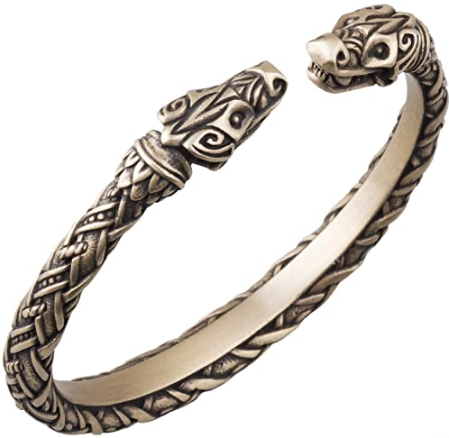
Torc of Tiamat (Minor)

Price 178,000 gp; Slot neck; CL 17th; Weight 1lb.; Aura strong transmutation

Cast from the elemental forge, this white platinum torc has pressed magical runes for each acid, cold, electricity, fire, and sonic energy types hammered into its form from atop the Anvil of Fire with a Rune Hammer, ending in two intricate carved Dragon heads. This item can be worn around the neck or upper arm.

When the user chooses to use their breath weapon they can choose from one type of energy (acid, cold, electricity, fire, or sonic), this energy type has to be different from their normal breath weapon energy type. This modification adds an equal amount of the chosen energy type to their breath weapon attack. So if the wearer breaths 10d6 necrotic, and they choose fire, then their breath weapon does 10d6 necrotic, and 10d6 fire.

Construction:
Cost 89,000 gp; Feats - Craft Wondrous Item; Spells - Breath Weapon Admixture (Spell Compendium, p. 39); Special - User must have a breath weapon ability.

