RING OF (EPIC) DIMENSIONAL FREEDOM
Price (Market): 480,000 gp; Body Slot: Ring; Caster Level: 21st; Aura: Strong; (DC 23) Abjuration; Activation: continuous; Weight: - lbs.

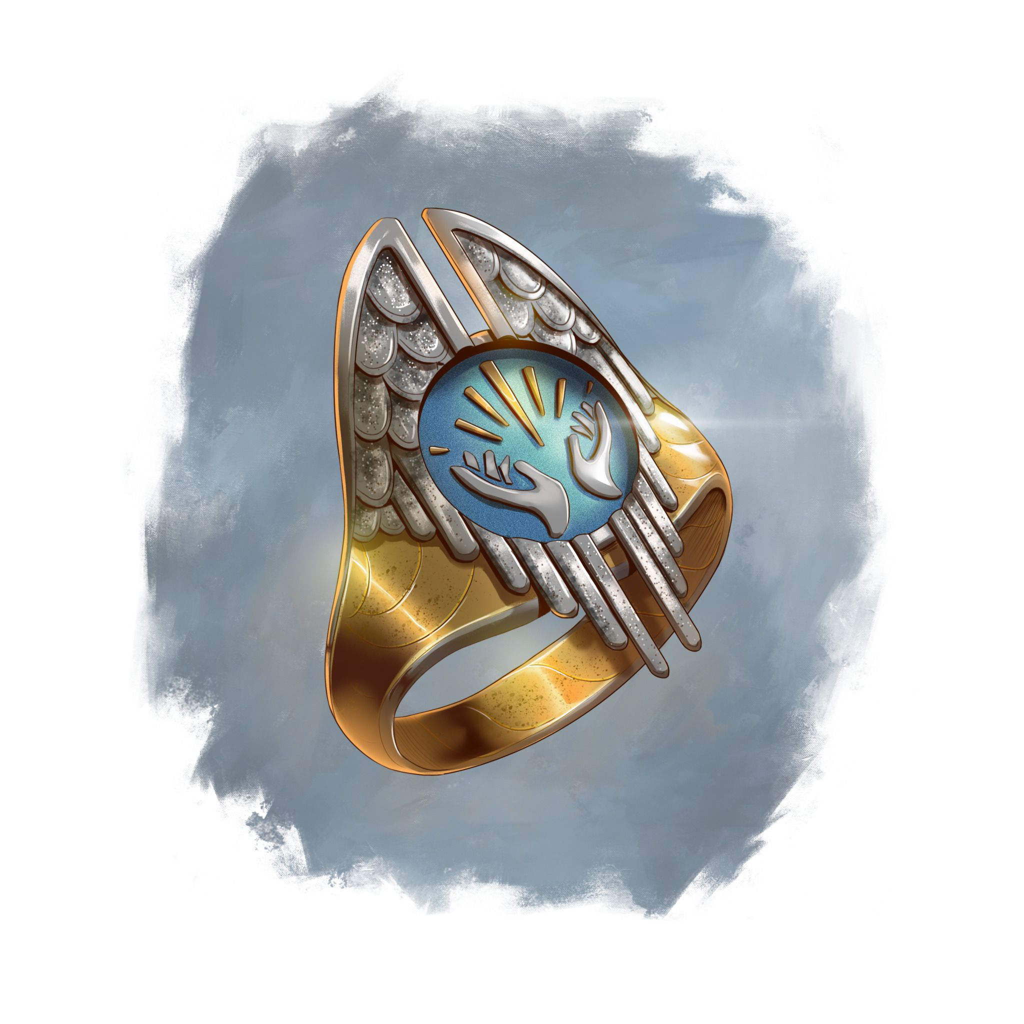
DESCRIPTION
“Two rings mana-welded together, each created from three strips of adamantine forming a simple band. The inner strip has a brushed metal finish, while the outer strips are polished to a shine, inset with a star sapphire gemstone.”
Each band confers a different immunity, continually providing the wearer with immunity to dimensional anchor, and dimensional lock.
Once the wearer is attuned to the item, the wearer can call the ring to them if the ring is on the same plane. Speaking the proper command word, regardless of the intervening distance. (as Called; MIC pg. 9).

Note: This item, is two separate rings they have been mana-welded together, and act as one ring (using one ring slot) conferring the effects of both rings.

Activation: Continuous
Body Slot: Ring

CONSTRUCTION REQUIREMENTS
Aura: Strong Abjuration
Caster Level: 21st
Craft Feat: Craft Epic Forge Ring
Craft Skill: Dwarvencraft (DC26), Gemcraft (DC20)
Socketed: (Open)
Material Components: Adamantium (2x bar), Mithril (2x bar), Star Sapphire (x2 stones), Manacite, Spellbreaker (x2)
Alchemical Reagents: Mind Flayer Ichor, Dragon Blood, Githzerai Essence
Dwarven Runes (Pressed): Anchor, Lock, Freedom
Item Properties: Called (+2,000gp)
Spells Prerequisites: Dimensional Lock, Dimensional Anchor, Spell Immunity (Greater) (x2)
Forge Tools: Elemental Forge, Runehammer, Anvil of Fire
Craft Price: 53,400gp

