RING OF THE MIGHTY WALLOP

Price (Market): 153,200 gp; Body Slot: Finger; Caster Level: 20th; Aura: Strong (DC 23) Transmutation; Activation: Continuous; Weight: 1 lbs.

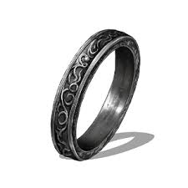
DESCRIPTION
“The head of the weapon you are wielding is suddenly encased in a radiant halo that only you can see, extending from the weapon to a distance of several inches.

This ring can be used in one of two ways; it can be worn by the wielder of a blunt weapon, or it can be molecularly bonded and mana-welded to the weapon. The forger of the ring initially intended for it to be merged with his weapon, but it can be used both ways. While the ring operates, a bludgeoning melee weapon damage increases by five size categories.

Table: Large and Smaller Weapon Damage (Link)
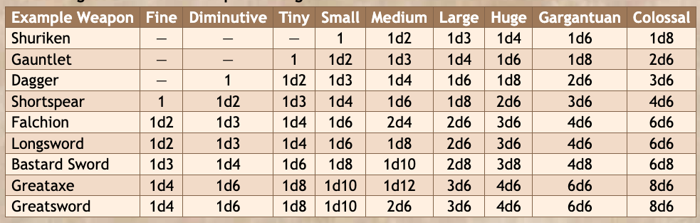

Activation: Continuous
Craft Skill (Dwarvencraft): +2 hardness, +10 item hit points and +2 to all saving throws
Restriction (Weapon): The weapon must have blunt weapon property
Socket(1): (empty)
Item Qualities: Socketed
Special Abilities: Called; Everbright
Body Slot: Finger
Category: Epic

RUNES
Master Rune of Battle Strength
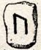
“This rune imprinted into the ring at forging bears the mark of a powerful build trait, allowing the wielder to handle weapons of impossible size relative to their physical dimensions.”
Function: (continuous) Can wield weapons one size category higher without penalty.
Price: +2 bonus

CONSTRUCTION REQUIREMENTS
Aura: (Strong) Transmutation
Caster Level: 20th
Craft Feats: Forge Ring
Craft Skill: Dwarvencraft [DC23], Gemcraft [DC23]
Socket (1): (Empty)
Dwarven Runes: Battle Strength [+1]
Material Components: Manacite (Rare), Diamonds (x3), Mithril (x1), Platinum (x1)
Alchemical Reagents: Dragon Tail Bone
Special Abilities: Called [+1); Everbright [+1]
Item Qualities: Socketed (+1200gp);
Spell Prerequisites: Mighty Wallop, Greater
Forge/Tools: Elemental Forge; Anvil of Fire, Manawelder, Molecular Bonder, Runehammer

