[EPIC] AMULET OF MERCY’S GRACE

Aura: Strong Evocation; CL 23rd; Slot: Neck/Throat; Price: 316,200gp; Weight: -

DESCRIPTION
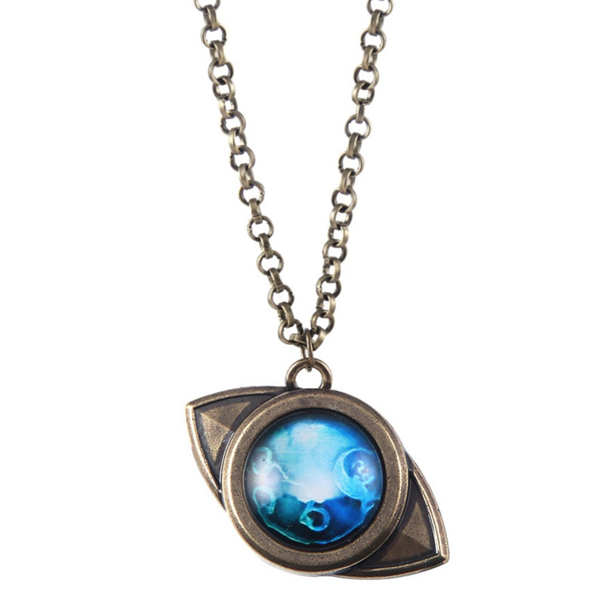
“This ornate mithril necklace is set with a brilliant, blue sapphire stone. Once worn, the amulet creates a shimmering, magical field around the wearer giving them a rush of mystical energy”

While wearing the amulet, the wearer gains the following benefits:
- Increase to spell’s save DC increases by 2, and its caster level increases by 1.
- 3/day a field of pure magic can be activated surrounding the wearer with a raw magical field.

The raw magical field suppresses any effects such as anti-magic field, a dead magic area, or null-magic plane effects that overlap the emanation. The emanation lasts for one round per caster level. If the wearer chooses to activate the amulet it requires a swift action, if the wearer is involuntarily inserted into an area of an anti-magic field, a dead magic area, or a null-magic plane the gem will use a reaction to trigger the field immediately. The wearer can choose to drop the field at any time as a free action.

Activation: Continuous
Craft Skill (Dwarvencraft): +2 hardness, +10 item hit points and +2 to all saving throws
Restriction (Amulet): n/a
Socket (1): (empty)
Special Abilities: Called; Everbright
Item Qualities: Socketed
Body Slot: Neck/Throat
Category: Epic

RUNES
Greater Rune of the SpellSword
“This rune pressed onto the amulet bearing the mark of the SpellSword Diety, the God of Magic Items, radiating powerful creation magics.”
Function: (activated)
Description: You can attempt to cast spells even within a dead magic zone or an antimagic field. In a dead magic zone, you must make a successful caster level check against a DC equal to 20 + the level of the spell yoare trying to cast. In an antimagic field, you must make a successful caster level check against a DC equal to 11 + the caster level of the antimagic field. If this check is successful, your spell functions normally.
Price: +5 bonus

CONSTRUCTION REQUIREMENTS
Aura: Strong Evocation
Caster Level: 23rd
Craft Feat: Craft Epic Wonderous Items
Craft Skill: Dwarvencraft [DC28], Gemcraft [DC23]
Socket (1): Empty
Dwarven Runes: Greater Rune of the SpellSword
Material Components: Mithril (x1), Blue Sapphire (1x), Platinum (1x), Spellbreaker(x1), Manacite (Radiant/Old)
Alchemical Reagents: Draconic Essence
Special Abilities: Called [+1]; Everbright [+1]
Item Qualities: Socketed [1,200gp]
Spell Prerequisites: Invoke Magic, Mystic Surge, Limited Wish
Forge/Tools: Elemental Forge; Anvil of Fire, Manacite Refiner, Manawelder, Hammer of the Dwarfsmith*, Gemcarver’s Tools

