[EPIC] RING OF ENERGY INVULNERABILITY

Aura: Strong Abjuration; CL 23rd; Slot: Finger; Price: 296,200gp; Weight: -

DESCRIPTION
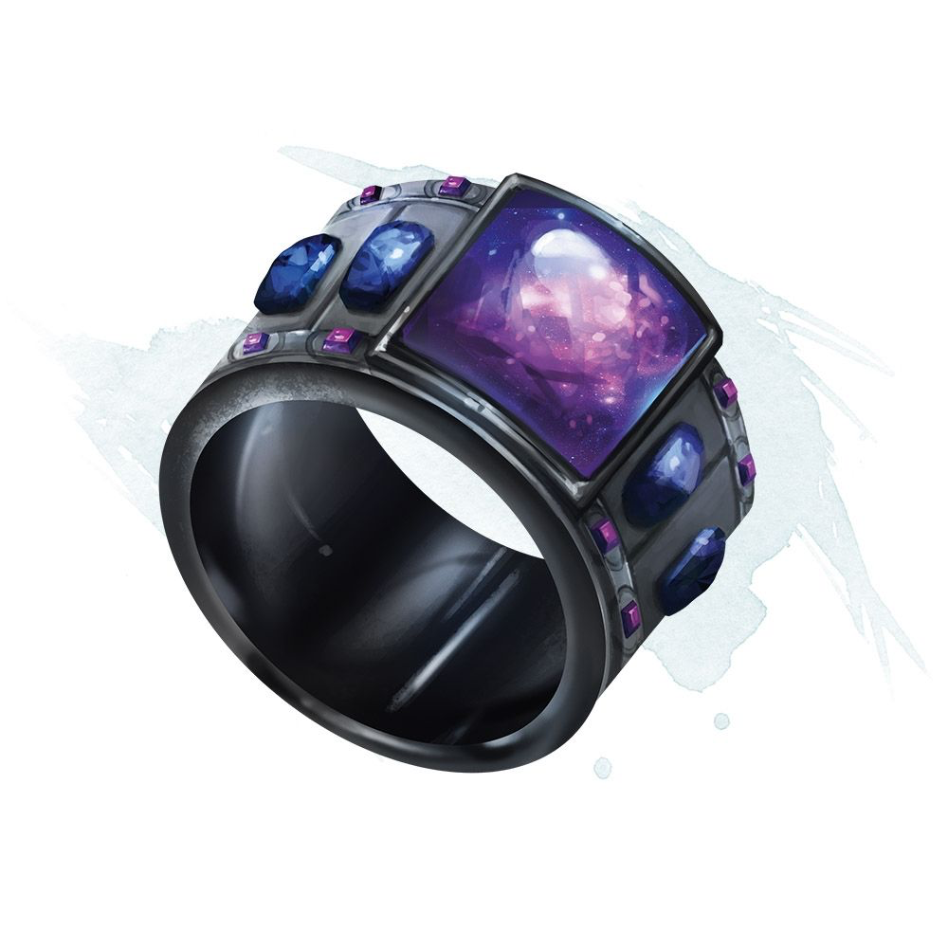
“This ornate mithril and platinum ring is set with a center brilliant, blue sapphire stone, and four smaller blue diamonds. Once worn, the rings elemental enchantments course thru the wearers body rendering them invulnerable to the elements.”

This ring functions as a ring of energy immunity for the 5 basic types of energy—fire, cold, electricity, acid, and sonic. The wearer takes no damage from energy of any of these types.

Activation: Continuous
Craft Skill (Dwarvencraft): +2 hardness, +10 item hit points and +2 to all saving throws
Restriction (Ring): n/a
Socket (1): (empty)
Special Abilities: Called; Everbright
Item Qualities: Socketed
Body Slot: Ring/Finger
Category: Epic

RUNES
Master Rune of the Elements
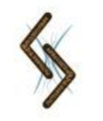
“This rune pressed onto this ring bears the dwarven rune for elemental magic, allowing the wearer to adapt to their elemental surroundings.”
Function: (activated - swift)
Description: 2/day – a wearer can adapt his body to a hostile environment. The change must be keyed to a specific surrounding: water, acid, extreme heat, extreme cold, an elemental plane, etc. If the power works, the user not only survives, but they can also behave like a native organism. He can breathe and move normally, suffering no damage from the environment. Duration: 1 round/level.
Price: +2 bonus

CONSTRUCTION REQUIREMENTS
Aura: Strong Abjuration
Caster Level: 23rd
Craft Feat: Forge Epic Ring
Craft Skill: Dwarvencraft [DC28], Gemcraft [DC23]
Socket (1): Empty
Dwarven Runes: Elements (Master)
Material Components: Mithril (x1), Platinum (x1), Blue Sapphire (1x), Blue Diamonds (4x), Manacite (Radiant/Old)
Alchemical Reagents: Draconic Essence
Special Abilities: Called [+1]; Everbright [+1]
Item Qualities: Socketed [1,200gp]
Spell Prerequisites: Invulnerability to Elements
Forge/Tools: Elemental Forge; Anvil of Fire, Manacite Refiner, Hammer of the Dwarfsmith, Gemcarver’s Tools

