Shield of the Protector

Price (Market): 187,500 gp; Body Slot: Offhand; Caster Level: 20th; Aura: Strong; (DC 21) Transmutation; Activation: Swift; Weight: - lbs.

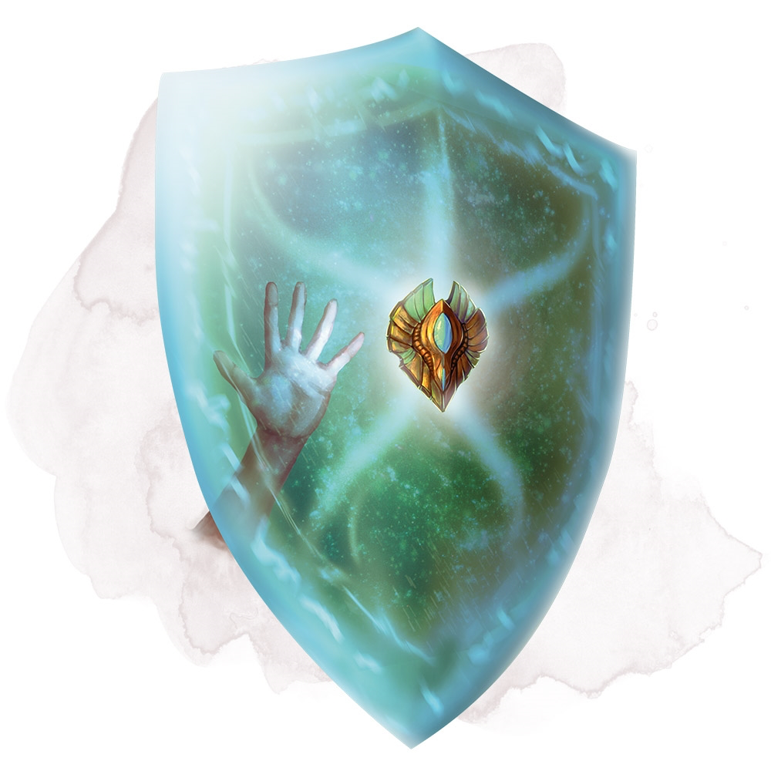
DESCRIPTION
“While holding this heavy spiked shield, you can speak its command word as a bonus action to cause it to animate. The shield leaps into the air and hovers in your space to protect you as if you were wielding it, leaving your hands free. The shield remains animated until you use a bonus action to end this effect, or until you are incapacitated or die, at which point the shield falls to the ground or into your hand if you have one free.”

The shield confers the following benefits:

- Shield Bonus: 4 [Base: +3; Reinforced: +1]
- Shield Enhancement Bonus: +5
- Socket (1): +5 insight bonus to AC
- You can benefit from only one shield at a time.

Lastly, the wearer can call the shield to them if they are anywhere on the same plane. Speaking the proper command word, regardless of the intervening distance. (as Called; MIC pg. 9)

Activation: Swift
Craft Skill (Dwarvencraft): +2 hardness, +10 item hit points and +2 to all saving throws
Restriction (Racial): n/a
Socket(1): (Ioun Stone) Dusty Rose Prism, Superior; +5 insight bonus to AC
Item Qualities: Reinforced; Blueshine, Dwarvencraft
Body Slot: Offhand
Category: Non-Epic

SOCKET
Dusty Rose Prism (Superior)
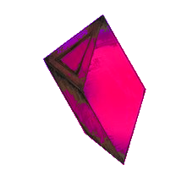
“An advanced form of ioun stone, cut from a rich gem vein out of range of mountains called the Crown. The Crown is a ring of mountains at the world’s edge that housed the first dwarves to come to this world; sadly, the forces of Chaos have overrun their once prestigious home. Making sourcing this gemstone a difficult task.”
Function: (continuous) +5 Insight Bonus to Armor Class.
Price: 62,500gp

CONSTRUCTION REQUIREMENTS
Aura: (Strong) Transmutation
Caster Level: 20
Craft Feats: Craft Arms and Armor
Craft Skill: Dwarvencraft [21]
Socket(1): Dusty Rose Prism (Superior)
Dwarven Runes: n/a
Material Components: Adamantium (5x Bars); Manacite (Very Rare); Spellbreaker (1x);
Alchemical Reagents: Dragon Scales
Item Properties: Socket [+1,200gp]; Reinforced (+1,200gp); Dwarvencraft [+600gp]
Special Abilities: Blueshine [+1]; Called[+1];
Spell Prerequisites: Limited Wish, Animate Object
Forge/Tools: Elemental Forge; Anvil of Fire, Mana-welder, Runehammer, Molecular-Bonder

