Bracers of Arcane Fusion

Price (Market): 195,400 gp; Body Slot: Arms/Wrist; Caster Level: 25th; Aura: Medium (DC 20) Transmutation; Activation: Continuous; Weight: 2.5 lbs.

DESCRIPTION
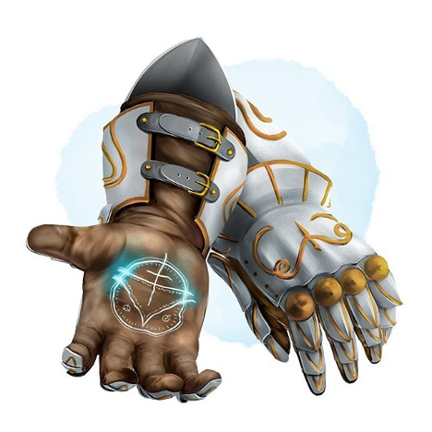
“You utter an ancient word tied to the fundamental principles of magic and immediately begin casting another spell, weaving two powerful spells together in your mind and releasing them in a single intertwined display of magical prowess.

When you cast a spell, choose any 4th-level or lower spell you know and any 7th-level or lower spell you know. Neither spell chosen can have a casting time longer than one standard action. Both spells take effect in the order you choose, as if you had cast them one after the other using only one standard action, the casters still must pay the spell point cost for both spells. Each of the chosen spells has its normal effect, including range, target, area, duration, saving throw, and spell resistance as appropriate to the spell's level.

These gauntlets enhance the wearer's armor class and spell-casting abilities making it more difficult for targets to resist.
- Increasing the caster level by +2.
- Increasing the save DC increases by 1.
- Armor Class Bonus: +2 / +1 (Reinforced) & +1 (Fortification Rune)
- Damage Reduction: 1/-;

Lastly, provided the wearer is attuned to the bracers, the wearer can call the bracer to them if they are anywhere on the same plane. Speaking the proper command word, regardless of the intervening distance. (as Called; MIC pg. 9)

Activation: Continuous
Restriction (Racial): n/a
Body Slot: Arms/Wrists
Category: Epic

RUNE
Rune of Fortification
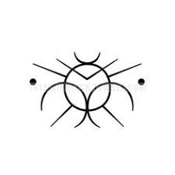
“Originally, created via forge song by the rune priests of the Great Rift to strengthen the Dwarven Defender shield wall against impossible numbers.”
Function: (continuous) Increases the wearer's armor class by +1 and their damage reduction by 1/-.
Price: +2

RUNE
Rune of the Arcane
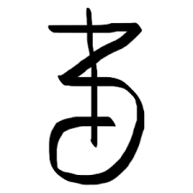
“The Rune of the Arcane glows green and yellow as the speed of thought flows thru the caster, hastening the spellcasting ability of the wearer.”
Function: (5/day) Allows the spellcaster to reduce the casting time of a spell from a standard action to a swift action.
Price: +3

CONSTRUCTION REQUIREMENTS
Aura: (Strong) Transmutation
Caster Level: 25th
Craft Feats: Craft Epic Wonderous Items
Craft Skill: Dwarvencraft [20], Acid Washed
Socket(1): Open
Dwarven Runes: Arcane, Fortification
Material Components: Adamantium (2x bars); Mithril (2x bars); Manacite (Very Rare); Spellbreaker (2x)
Alchemical Reagents: Dragon Leather; Mind Flayer Membrane and Blood; Manaethereal Troll Tusks (Ivory)
Item Properties: Socketed [+1200gp]; Reinforced [+1200gp]
Special Abilities: Called [+1], Blueshine [+1];
Spell Prerequisites: Spell Enhancer, Arcane Fusion (Greater), Forge Chant (Dragon Magazine #245)
Forge/Tools: Elemental Forge; Anvil of Fire, Mana-welder, Runehammer

