Spear (+6) of Insidious Impaling

Aura: Strong Abjuration; CL 23rd; Slot: Primary; Price: 142,305gp; Weight: 8lbs

DESCRIPTION
“The barbed head of this spear sits atop an adamantium shaft that seems to writhe and vibrate as though something lives within the spear. Fixed to the bottom of the spear sits a longtooth barbed blade; it looks as though it can be shot from the end of the spear.

After a successful hit, the attacker that used the spear of impaling may make an opposed grapple attempt at their BAB + Strength Mod + size modifier + any feat bonuses.
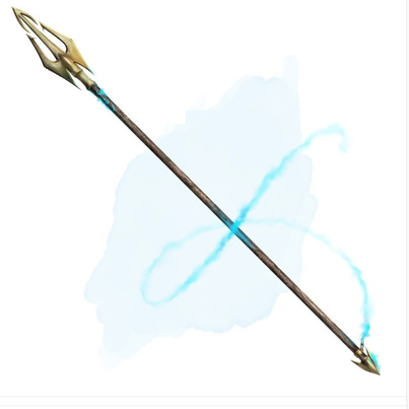
If this grapple attempt succeeds, the following effects take hold:

- Tentacle barbs (liquid quicksilver slaad tongues) spread throughout the foe’s body, hardening around internal bones and organs, making it very challenging for the foe to move.
- The foe is subject to the effects of a dimensional anchor and forced shape change.
- An adamantine spiked chain shoots out from the opposite end of the spear, anchoring itself to any nearby surface, attaching the anchored point of the surface and the chain to the fabric of the plane. Any creature attempting to move physically must succeed on an opposed Strength check; the spear uses the strength profile of its wielder at a +30 bonus on the check.

If the grapple attempt fails, the foe is not subject to any other effects; the foe takes normal ranged attack damage.

Provided the wearer is attuned to the spear, the wearer can call the spear to them, retracting the quicksilver tentacles and the barbed chain. If they are on the same plane, the spear teleports back to its owner's hand. Speaking the proper command word, regardless of the intervening distance. (as Called; MIC pg. 9)

Activation: Continuous
Body Slot: Primary

CONSTRUCTION REQUIREMENTS
Aura: Strong Abjuration
Caster Level: 23rd
Craft Feat: Craft Magic Arms and Armor
Craft Skill: Dwarvencraft (DC26)
Socket(1): (empty)
Dwarven Rune(s): n/a
Material Components: Adamantium (4x), Mithril (1x), Manacite (Rare), Spellbreakers (2x), Longtooth, Dagger (2e)
Alchemical Reagents: Alchemical Quicksilver Infused Slaad Tongues
Item Properties: Socketed [+1200gp]; Reinforced [+1200gp]
Special Abilities: Called [+1], Blueshine [+1];
Spell Prerequisites: Baleful Polymorph, Forced Shape Change, Dimensional Anchor, and Immovability.
Forge/Tools: Elemental Forge; Anvil of Fire, Manacite Refiner, Manawelder, Hammer of the Dwarfsmith

